The devil wears Prada
Episode 1

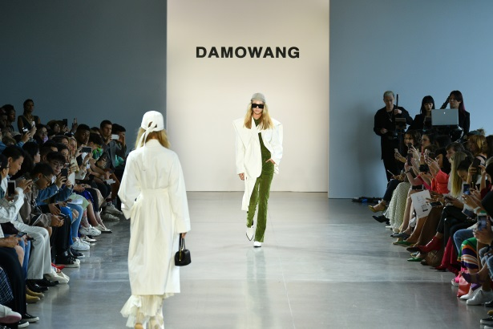
Discussion: Fashion

- Are you interested in fashion?
- Do you read any fashion magazines or watch any fashion programs?
- Do you think if it is important to follow fashion or not? Why?

The essential vocabulary:

An appointment - встреча (назначенная)
Human Resources - менеджер по подбору персонала
An odd sense of humor - странное чувство юмора
Get promoted - получить повышение
To sack - уволить
Survive - выживать
Pretend - притвориться
Editor - редактор
Crucial - критически важный, необходимый, ключевая роль
Be supposed to do - быть должным что-то делать
Facialist - визажист
Rupture a disk - повредить межпозвоночный диск

- Translate the phrases:
- Human Resources certainly has an odd sense of humor.
- So I was Miranda's second assistant...but her first recently got promoted, and now I'm the first.
- We need someone who can survive here.
- It sounds like a great opportunity.
- Runway is a fashion magazine, so an interest in fashion is crucial.
- She's not supposed to be here until 9.
- God, these people.

- Watch the episode and answer the questions:

- Who is Andrea?
- Why does she come to the company?
- What’s the name of the company?
- Who is Miranda?
- How many assistants did Miranda sack?
- What time is Miranda supposed to be at the office?
- Why is she coming earlier?

- Watch the episode again and fill in the gaps:

Good luck.
Hi. I have an _______________________ with...Emily Charlton?
- Andrea Sachs?
- Yes?
Great. Human Resources certainly has an ______________________humor. Follow me.
Okay. So I was Miranda's second assistant...but her first recently got promoted, and now I'm the first.
- You're replacing yourself.
- Well, I am trying.
Miranda _____________the last two girls after a few weeks. We need someone who can ______________________ here.
- Do you understand?
- Yeah, of course. Who's Miranda? Oh, my God. I will pretend you did not just ask me that. She's the editor in chief of Runway. Not to mention, a __________________.
Work a year for her and you can get a job at any _______________you want. A million girls would kill for this.
- It sounds like a great opportunity. I'd love to be considered.
Andrea...Runway is a fashion magazine, so an interest in fashion is___________________.
What makes you think I'm not interested in_______________?
Oh, my God. No, no, no!
What's wrong?
She's on her way. Tell everyone. She's not supposed to be here until 9.
Her driver just text-messaged, and her facialist ruptured a disk. God,__________________.
- Who 's that?
- That I can't even talk about.
- All right, everyone. Gird your loins!

- Translate into English:

- О, Боже! Она уже в пути. Её шофёр только что написал мне смс.
- Если вы хотите работать в модном журнале, то интерес к моде является ключевым моментом.
- Что-то не так?
- Нам нужен кто-то, кто сможет выжить на этой работе.
- Она должна была прийти к девяти.
- Это звучит, как отличная возможность.

- Retell this episode from a) Andrea’s b) Miranda’s assistant’s point of view

